The Mahomet aquifer that underlies 13 counties in east-central Illinois and is connected to the Sangamon River via a hydraulic window that allows the Mahomet aquifer water to discharge to the river under normal conditions but allows the river to recharge the aquifer as well when the river is high or the aquifer is being pumped. While the age of the water varies from less than 1,000 to 12,000 years, there was trace amounts of pesticides in the water as well as arsenic that was above the accepted drinking water standards.

The current arsenic drinking water maximum contaminant level is 10 μg/L (U.S. Environmental Protection Agency, 2001). Arsenic was found at elevated levels in the Mahomet aquifer, up to 84 micrograms per liter (μg/L). Samples from 83 percent of the domestic wells had arsenic detections (greater than 1 μg/L), and 43 percent had arsenic concentrations greater than 10 μg/L (Warner, 2001).

Therefore, the water would need to be purified before it would be acceptable for human consumption; however, it would be applicable for light industrial uses, such as the electrolysis of water.

Hydrogen is generated through the electrolysis of water in the following formula:
2H₂O + Energy → 2H₂ +O₂
This reaction occurs in an electrolytic cell that is exposed to an electric current starting the process of electrochemical separation of water molecules into its two components. The gases are emitted from the electrode and are separated and captured in the cell. Following that, the gases go through a back flash valve, water trap and dehumidifier before they are ready for use.

Hydrogen can be produced in small units near it’s intended point of usage, in a manner known as "distributed production." Distributed production may be the most viable approach for introducing hydrogen in the near term, in part because the initial demand for hydrogen will be low.

A hydrogen economy requires an infrastructure to deliver hydrogen from where it's produced to the point of end-use, such as a dispenser at a refueling station or stationary power site. Our project will be facilitated by our proximity to the interstate highway system. If we utilize the area north of town we will be directly off I-74 and if we use the area southwest of town we can access either I-74 or I-57. Infrastructure includes the pipelines, trucks, storage facilities, compressors, and dispensers involved in the process of delivering fuel. However, we could make small modifications to the natural gas pipeline system that currently exists and make it applicable to hydrogen as well.

We would most likely implement the HGeneratorsTM 3000W Wind Turbine Electricity Generator. It can produce both electricity and hydrogen approximately 600kWh per month using an average wind speed of 12m/s and 210h per month. The cost is just under $6,000 for the entire wind turbine. The following table can be found on the company’s website located at: http://www.hgenerators.com

Specifications:
Rated power: 3000W | Protection level: IP54
Peak power: 3400W | Insulation level: B
Wind wheel diameter: 5m | Cooling Mode: IC0141
Start-up wind speed: 2m/s | Operation Temperature: -40C~60C
Cut-in wind speed: 2.5m/s | Drive Mode: Direct Driven by Wheel
Rated wind speed: 10m/s | Adjust Speed Mode: Automatic
Stop wind speed: 25m/s | Adjust Direction Mode: Manual/Automatic
Survival wind speed: 45m/s | Tower Height: 9m
Rated rotate speed: 400r/m | -Rated voltage: 240V

  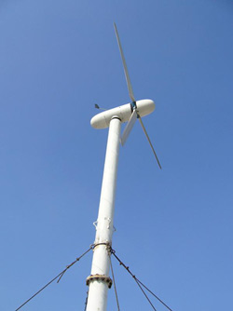
  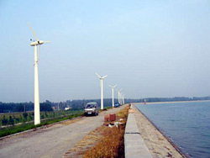
  Components and Annex:
  1. Tower base, Pivot bolt and nut
  2. Tightwires
  3. Tightwire clamps
  4. Turnbuckles
  5. Anchor
  6. Pulley
  7. Bolts and nuts
  8. Anemoscope
  9. Anemoscope pole
  10. Dogvane
  11. Generator assembly
  12. Dome
  13. Controller
  14. Ground nail
  15. Tower
  16. Assistant tower
  17. Blades
  18. Inverter
  Note: The cables and batteries should be purchased according to your own specific situations.
  Proposed battery configuration for this generator is twenty 12V100AH batteries.

