 |  |  |  |  |  |  |  |  |  |  | Application for Mobile  Crane Registration
Mail, Fax, or Email Application to: |  |  |  |  |  |  |  |  |  |  |  | IDOT Use Only
Illinois Department of Transportation |  |  |  |  |  |  |  |  |  |  |  | Classification
2300 S. Dirksen Pkwy., Rm. 117
Springfield, IL 62764 |  |  |  |  |  |  |  |  |  |  |  | IDOT Decal Assigned
Fax: (217) 782-3573 |  |  |  |  |  |  |  |  |  |  |  | Fee Paid
Email: Permitoffice@dot.il.gov |  |  |  |  |  |  |  |  |  |  |  | Registration Expires
Owner |  |  |  |  |  |  |  |  |  |  |  | Account Number
Address
City |  |  |  |  |  |  |  |  |  | State |  |  |  |  |  |  |  |  | Zip
Make, Model and Year of Crane |  |  |  |  |  |  |  |  |  |  |  | Serial Number
Make, Model and Year of Carrier |  |  |  |  |  |  |  |  |  |  |  | Serial Number
Is the loading on any axle capable of being controlled independently from the other axles? |  |  |  |  |  |  |  |  |  |  |  |  |  |  |  |  |  |  |  | Yes |  |  | No
If yes, explain
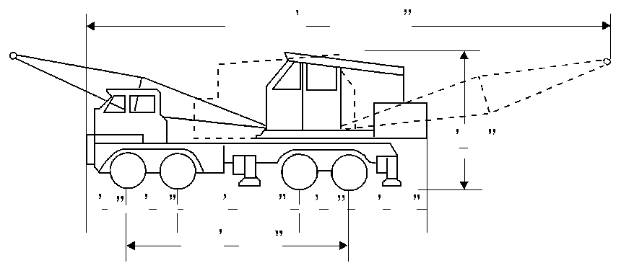
Maximum gross weight |  |  |  |  |  |  |  |  | pounds |  | Maximum overall width |  |  |  |  |  |  |  |  |  |  | feet
I certify that the above statements are true and correct.
 | Date |  |  |  |  |  |  |  |  |  |  | Signature
 |  |  |  |  |  |  |  |  |  |  |  | Official Capacity

Printed 4/28/2006 OPER 988 (Rev. 4/06)

Completion of the Application for Mobile Crane Registration

The applicant must furnish all of the information required in the application forms. A separate application must be submitted for each vehicle to be registered.

The completed application, with the required fee of $5.00, should be mailed to the Illinois Department of Transportation, Bureau of Operations, Attention: Special Vehicle Movement Section, Springfield, Illinois 62764.

Issue of IDOT Identification Decal

Following analysis of the vehicle, the Department will issue an IDOT Registration Number and Identification Classification Decal, which will be affixed to the vehicle to which it applies. Specific information regarding the vehicle is then on file with the Department and this data may be used in the analysis of routes and structures.

In requesting permits for the movement of overweight vehicles, only the Classification Identification need be used provided the limitations of the classification are not exceeded. If the classification limitations are exceeded, the applicant may use the Registration Number to specifically identify the vehicle to be used.

The effect of not having the identification decal displayed on the vehicle being operated, when such vehicle is identified in the permit by IDOT Classification or IDOT Registration Number, shall be the same as though no permit has been issued and the driver or owner of the vehicle being operated, in addition to a charge of violating Section 15-319 of the Illinois Vehicle Code, will be charged with exceeding all maximum size and weight limitations stipulated in Sections
15-102 through 15-111.

Classifications

The following classifications will be utilized:

- Class M Mobile Crane. A 4-axle mobile crane; pounds gross; 32,000 pounds on one tandem; 40,000 pounds on the other; wheelbase 23 feet or more; less than 12 feet wide; not over 60 feet long.

- Class N Mobile Crane. A 3 or 4-axle crane; 60,000 pounds gross; 20,000 pounds per axle, wheelbase 18 feet or more; less than 12 feet wide ; not over 60 feet long.

Mobile Cranes that do not meet the specifications established for registration within one of the aforementioned IDOT Classifications will not be registered and all applications and fees will be returned to the applicant.

Printed 4/28/2006 OPER 988 (Rev. 4/06)

