David Lartonoix
NPRE 498
Wind Power

In order to install a wind park on Yankee Ridge in Champaign County, Illinois, an in-depth analysis of the capacity of local roads to handle the heavy machinery required is essential. Several factors must be investigated to ensure that the proper preparations have been made before the arrival of the large sections of the turbine. In addition, the cranes required to hoist the tall portions of the turbines are typically extremely heavy. Perhaps the most important preparation to be made is the proposed route of delivery. This decision itself should be based upon road weight restrictions, height restrictions, and permit requirements.

The best source of information for this type of project is the Illinois Department of Transportation. They have created a website that was instrumental in planning out the route for the Yankee Ridge Wind Park. This link shows overweight truck routes, permit information, etc for roads in the local Champaign area:

http://www.gettingaroundillinois.com/default.aspx?ql=dtr#

After evaluating several possibilities, it was decided that the best way to transport the heavy wind turbine components and the machinery required for installation to Yankee Ridge was to ship everything from I-57/I-74 down to the Neil Street exit, US-45. The transport trucks will exit onto US-45 and turn north. This can be seen in Figure 1. This will take them through the towns of Pesotum and Tolono, continuing north on US-45/Neil St. until approaching Willard Airport, just south of Savoy. The transport vehicles will turn east on E900N, Champaign County Road 18. This can be seen in Figure 2. This county road will be taken all the way to the wind park access roads on top of Yankee Ridge.

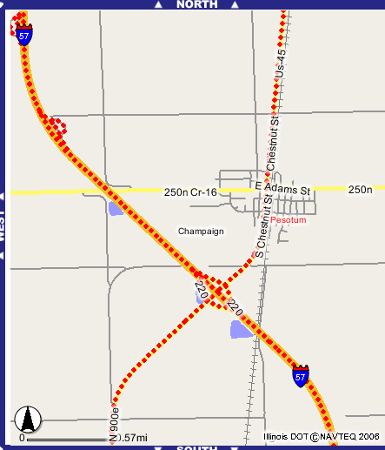

Figure 1

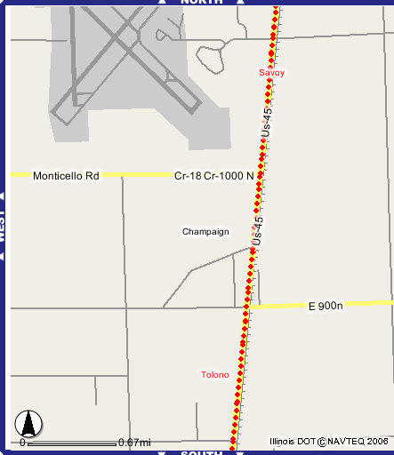

Figure 2

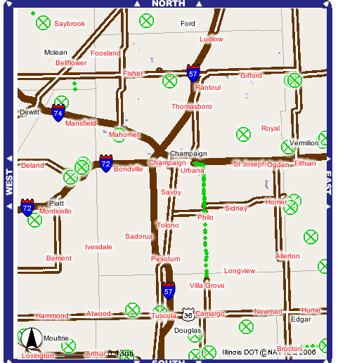

Figure 3

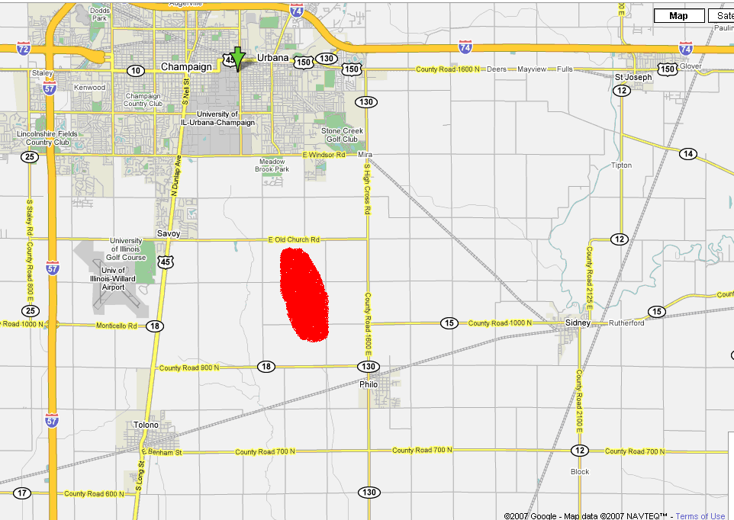

Figure 4
The proposed route was based upon several important factors. First, the weight of such heavy machine components and installation equipment must not be in excess of what the roadways can support. This is of special concern for the local rural roads, as Yankee Ridge is located in a predominantly rural area. The State of Illinois has determined that the sections of road marked with red dots in the above figure have been approved for:

120,000/6-Axle TST; Drive Tandem 48,000; Semi Tandem 60,000
100,000/5-Axle TST; either tandem 48,000
76,000/4-Axle vehicle; one Tandem 34,000, other Tandem 44,000
68,000/3-Axle vehicle; single Axle 20,000, Tandem 48,000

Vehicles in this range of weight must apply for an overweight permit. Although it is unknown at this time exactly how much the turbine assemblies will weigh, the above standards are well above the proposed value. From sources cited later in this paper, no single component should weigh more than 18 tons, a weight that can easily be handled by the approved roadways.
Thus, the only stretch of roadway in question is the E900N, Champaign County Route 18. This road is a Class II throughway (see Figure 3), however, and should be able to handle most loads expected during the turbine installation. If anything, this road might require some additional shoring up. Since it is less than 4 miles in length, this greatly reduces the cost of installation, which can be a huge obstacle in the installation of a wind farm.
In addition to the approximately 4 miles of Route 18 that may need reinforcement, the Yankee Ridge farm will require its own access roads. These must also be custom built to accommodate the weight and will require a significant expense. An estimate of 5 miles of access roads must be built. Although this is expected to be a significant cost, this is a relatively short distance for such a large wind park. It is also considerably less than other wind farm projects already in operation which require in excess of 10 miles of access roads.
Although vertical restrictions were not explicitly examined in this study, a preliminary prognosis can be mentioned, requiring further study. A power/telephone line crosses perpendicular to E900N, Champaign County Route 18 at 1200E and is about twenty feet off of the ground. Any vehicles bound for Yankee Ridge must be able to pass underneath these cables. If this cannot be accomplished, the local utilities can be contacted to temporarily move or re-route the cables. Although a certainly reasonable request and fairly simple to accomplish, this will simply require an additional amount of preparation, but nothing more than a minor additional expense. Further vertical restrictions should be examined in the towns of Pesotum and Tolono. Although rigid traffic control devices and powerlines exist along the proposed route, especially on Neil Street, no extreme measures of rectification are anticipated.
This route was chosen over other possibilities after careful consideration. First, South High Cross Road would be very capable of handling the weigh load and its proximity to the site makes it an alluring choice (see Figure 4, Yankee Ridge Site in red). However, it does not connect to I-74, and maneuvering large or overweight object through the side roads from I-74 to South High Cross Road was deemed impossible. Furthermore, 2200E Champaign County Road 12, which does connect to I-74, was also excluded from handling large or overweight objects. This was because of several ninety degree turns required to get from it to 1000N Country Road 15 to South High Cross Road and the uncertainty of the weight limits on these country roads.
Finally, if the proposed route does not prove to be a viable option, there are two remaining options, albeit neither is exactly practical. First, several rail lines criss-cross the territory, and one particular line comes in close proximity of the site. A rail line runs through Philo and, if the blades and machinery could be arranged to get from the train station to South High Cross road, running through Philo, this could prove to be an acceptable solution. Here, the distance traveled on roadways is greatly reduced, but the possibilities of rail transport were not examined. Second, a heavy lift helicopter could always transport the machinery directly to the site. The site is very close to Willard Airport, which could act as a staging base for the operation. This has been done already in other countries, but was known to be extremely expensive. Please see attached photographs. This event entailed utilizing a Russian heavy-lift helicopter to install several turbines in the Swedish wilderness in 2002. The project was undertaken by NEG Micon and was meant to “gain experience of turbine erection out in the wilderness, where there is no access to sites via ordinary roads.”
