Application of Redox-active Polymers (RAPs) for energy Storage in Redox-Flow Batteries (RFBs)
Zirui Wang
ziruiw2@illinois.edu
University of Illinois, Urbana-Champaign
Term Paper: NPRE 498, Fall 2023

Introduction
Global warming is an imperative problem faced by human beings. According to the 2022 annual report of National Centers for Environmental Information¹, 2022 is the sixth warmest year since global temperature recordings emerged in the 1800s. Furthermore, the warmest ten years in the history are all recorded after 2010, and this fact emphasizes the rapidness and severity of global warming.

Figure 1: The annual global temperature data since 1880.

It has been long since the concept of energy storage comes into place. Originally, energy storage aims to improve the energy conversion efficiencies of power systems, such as nuclear power plants, by collecting and storing the energy loss throughout the power generation process.
However, energy storage nowadays also aims for providing a clean energy source. For instance, solar panels uses solar energy to generate heat and electricity, and wind power systems takes advantages of wind to produce electricity. However, a key problem to these techniques is: they face intermittences. Namely, solar energy cannot be used during the night, and wind energy cannot be produced when there is no wind. Thus, energy storage systems without intermittence problem are also attractive.
Among all the energy storage systems without intermittence, batteries are one of the most commercialized, developed, and researched technique. The operating principle of batteries is based on electrochemistry. Consider the chemical reaction below:
$$A⟹B$$
The energy required to drive this reaction is the Gibbs free energy difference between B (the product) and A (the reactant). If the reaction is downhill, which means the product has a lower Gibbs free energy than the reactant, the reaction is spontaneous. Similarly, one can consider a set of heterogenous chemical reactions that happen in a lithium-ion battery:
Cathode: $CoO_{2}+Li^{+}+e^{-}⇌LiCoO_{2}$
Anode: $LiC_{6}⇌C_{6}+Li^{+}+e^{-}$
Overall: $LiC_{6}+CoO_{2}⇌LiCoO_{2}+C_{6}$
A lithium-ion battery is an electrochemical cell. The voltage one can get out of the electrochemical cell is described by the following equation:
$$E=-\frac{∆G}{nF}$$
In the equation above, $∆G$ is the Gibbs free energy difference between the products and the reactants in the overall reaction. $n$ is the total number electrons transferred. $F$ is the Faraday’s constant (96485 C/mol). Thus, if the overall chemical reaction of an electrochemical cell is spontaneous ($∆G<0$), one can convert the chemical energy from the spontaneous reaction to electricity².

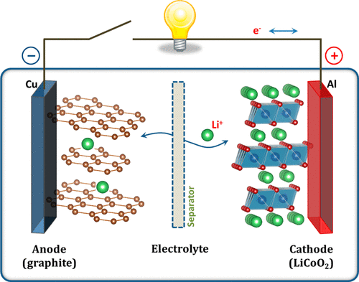
Figure 2: The structure of a lithium-ion battery.

Batteries are clean energy storage technique and have lots of unique advantages. First, they are versatile. They can be used in a range of systems, ranging from portable electronic devices to vehicles or spacecrafts. Second, they can convert chemical energy to electricity instantaneously and can be recharged, therefore possessing negligible intermittence problems. Third, batteries have good specific power and energy density, making their performance comparable with traditional energy sources such as fossil fuels. Lastly, the operation of batteries does not emit carbon dioxide, a greenhouse gas that causes global warming.
Redox-flow battery (RFB) is a type of battery that contains two tanks of liquid-state electrolytes called catholyte and anolyte respectively. When the battery is being operated, electrolytes are pumped into the electrochemical cell in the middle. Electrochemical reduction reaction will happen on the cathode side, while electrochemical oxidation will happen on the anode side. Since the overall reaction is spontaneous, electricity can be obtained from an RFB³.

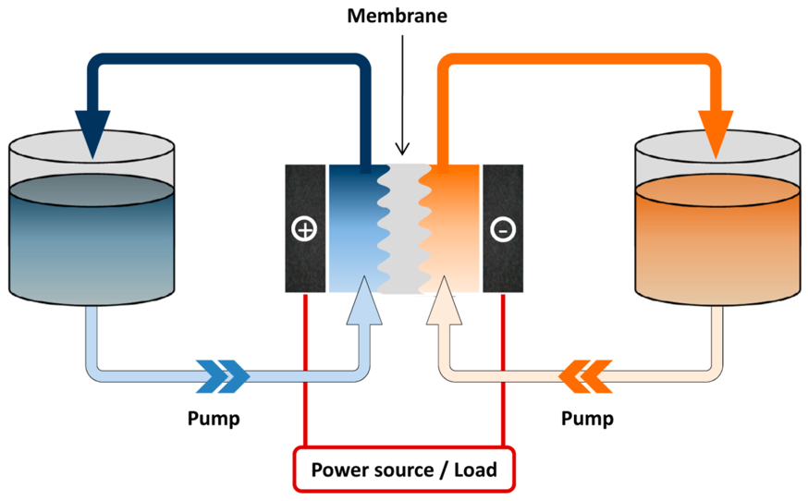
Figure 3: The setup of an RFB.

Although traditional RFBs has no capacity limit (i.e. One can simply build larger electrolyte tanks to obtain a larger capacity), and is thus suitable for grid energy storage, they have low energy density as the media to store the charges are in liquid form. Furthermore, most of the current RFBs are vanadium-based, and vanadium, as a rare-earth metal, has economic concerns. Currently, there are a lot of research going on to make RFBs have a better energy density and cheaper cost.

Redox-active polymers (RAPs)
Polymers are molecules that contains a large number of repeating units called monomers. Because of their high molecular weight, polymers are oftentimes referred as macromolecules. Out of all kinds of different polymers, there is one category called redox-active polymers (RAPs)⁴.

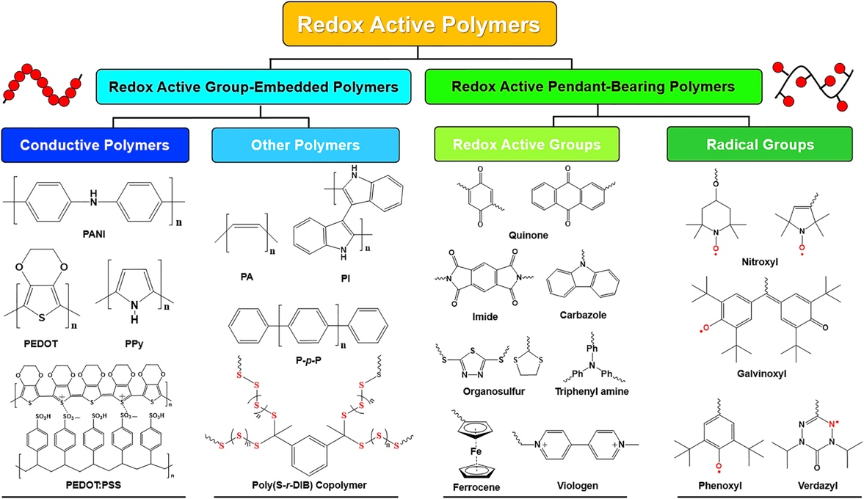
Figure 4: Different categories of RAPs.

RAPs are considered to be the alternatives for traditional vanadium-based electrolyte for RFBs because of their (1) high energy density (2) cheaper cost (3) ease of synthesis. Lots of research are being conducted on various kinds of RAPs, but the most important kinds of RAPs are redox active group-embedded polymers and redox active pendant-bearing polymers.

Redox Active Group-Embedded Polymers
When a polymer has continuous π-bonds, the polymer is called conjugated polymer. In a simpler word, if a polymer has continuous double or triple bond, it can be categorized as conjugated polymer. If a polymer has a redox active backbone, this polymer is a redox active group-embedded polymer. If the redox active group-embedded polymer is conjugated, then the polymer is conductive, because charges can propagate throughout the polymer by the continuous π-bonds. Thus, some redox active group-embedded polymers are also referred to as conductive polymers. Polypyrrole⁵, as an example, is one of the mostly researched conductive polymer.

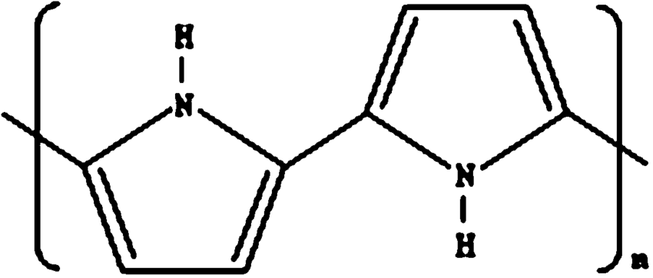
Figure 5: The chemical structure of polypyrrole (Ppy), a widely researched redox-active group-embedded polymer.

One special property that a redox active group-embedded polymer has is: it allows a so-called “redox targeting” mode to be achieved in RFBs. In redox targeting⁶, in additional to the electrolyte, a layer of redox active group-embedded polymer is added into the system. After the electrolytes have been pumped into the electrochemical cell in the middle and redox reactions have taken place to electrolyze the electrolytes, the electrolyzed electrolytes are pumped into the tank that contains the redox active group-embedded polymers. A chemical reaction will happen between the electrolyte species and the redox active group-embedded polymer. After this process, the electrolyzed electrolyte will retain its original form, and the charges that require to convert the electrolyte back to its original form is mediated by the redox active group-embedded polymer and will be transferred to the external circuit.
This redox targeting mode of RFB operation significantly improves the energy density of the system because the charges are essentially stored inside the redox active group-embedded polymer, which is a solid-state medium that inherently has a higher density. Furthermore, the amount of electrolyte does not matter in RFBs in the redox targeting mode, because the capacity of the battery solely depends on the amount of charge the redox active group-embedded polymer can mediate before being replaced. Therefore, if a redox active group-embedded polymer that has a good capacity can react with the electrolyzed form of the electrolytes fast enough, RFBs can have a much larger energy density.

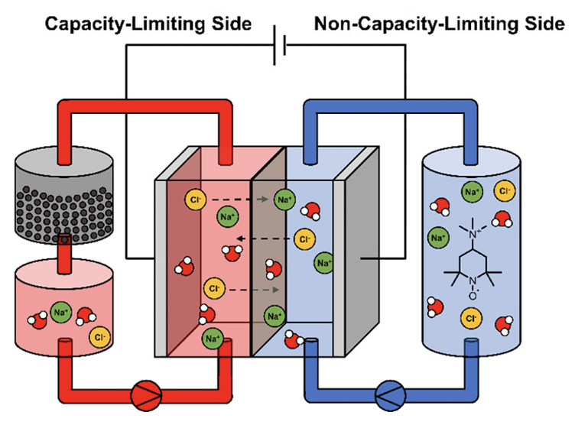
Figure 6: The operational mode of a redox targeting RFB.

One of the disadvantages of redox active group-embedded polymers is: incorporating the redox targeting mode of RFBs adds complexity to the system. One needs another one or two pumps to pump the electrolyte into the chamber. Furthermore, one still needs to replace or charge the redox active group-embedded polymers so that the redox targeting mode can be continuously achieved. Second, the redox active group-embedded polymers are still mostly in the research stage.

Redox Active Pendant-Bearing Polymers
Unlike redox active group-embedded polymers, redox active pendant-bearing polymers have a backbone that is not conductive. However, one can attach redox active functional groups onto the polymer backbone, and this process is commonly referred as chemical grafting.
Theoretically, there is no limitation on the number of redox-active functional groups that can be attached to the backbone of the polymer⁷. When these redox active pendant-bearing polymers are dissolved into solution and undergo electrochemical reactions, all the redox-active groups can react simultaneously. Thus, multiple electron transfer events can occur on a single redox active pendant-bearing polymer molecule at the same time. Thus, the energy density is significantly improved, as for traditional inorganic electrolytes, only one or two electrons can be transferred to a single molecule.
The capacity of RFBs that apply redox active pendant-bearing polymers is only limited by (1) The amount of redox active functional groups that can be attached to the polymer backbone (2) The solubility of the redox active pendant-bearing polymers inside the electrolyte solution. Although in this way the RFBs use a completely different electrolyte, the setup is still same.
Despite the advantages redox active pendant-bearing polymers possess, there are some main drawbacks. First, the behavior of redox active pendant-bearing polymers is significantly dependent on the solvent. The amount of salts in the solvent may affect the morphology of the redox active pendant-bearing polymers and thus complicates the electron transfer process a lot. Second, redox active pendant-bearing polymers have totally different solution dynamics compared to traditional aqueous electrolytes. Aqueous electrolytes are typically non-viscous, while most organic electrolytes are highly viscous. Viscosity will slow down the transfer of redox active pendant-bearing polymers to the electrochemical cell, which will add internal resistance to the RFBs.

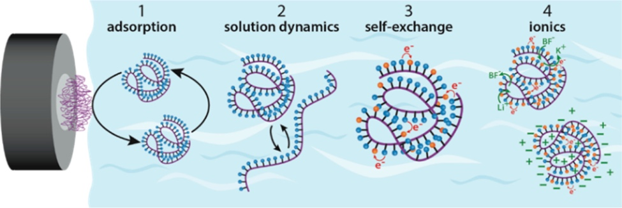
Figure 7: the chemical structure of redox active pendant-bearing polymers and different processes that can affect their performance.

Although redox active pendant-bearing polymers are also still in the research stage, due to its high energy density, ease of synthesis, and ease of use, it is a promising substitute for traditional metal-based electrolytes for RFBs.

Summary
Redox-flow batteries (RFBs) are a promising clean technique for grid-energy storage. However, traditional vanadium based RFBs have cost and energy density issues. To circumvent the issues that traditional RFB electrolytes possess, one should consider finding substitutes for traditional electrolytes. One of the most promising substitutes is redox-active polymers (RAPs). One can use redox active group-embedded polymers and use RFBs in the redox targeting mode to improve the capacity and energy density of the system. However, this mode is more complicated and needs additional apparatus. Alternatively, one can use redox active pendant-bearing polymers as flowable electrolytes to achieve the same effects. However, the performance of redox active pendant-bearing polymers is complicated and thus requires more systematic research.
Reference:
[1] NOAA. Annual 2022 global climate report | national centers for environmental Information (NCEI). www.ncei.noaa.gov. https://www.ncei.noaa.gov/access/monitoring/monthly-report/global/202213.
[2] Goodenough, J. B.; Park, K.-S. The Li-Ion Rechargeable Battery: A Perspective. Journal of the American Chemical Society 2013, 135 (4), 1167–1176. https://doi.org/10.1021/ja3091438.
[3] Pan, F.; Wang, Q. Redox Species of Redox Flow Batteries: A Review. Molecules 2015, 20 (11), 20499–20517. https://doi.org/10.3390/molecules201119711.
[4] Kim, J.; Kim, J. H.; Ariga, K. Redox-Active Polymers for Energy Storage Nanoarchitectonics. Joule 2017, 1 (4), 739–768. https://doi.org/10.1016/j.joule.2017.08.018.
[5] Arshak, K.; Velusamy, V.; Korostynska, O.; Oliwa-Stasiak, K.; Adley, C. Conducting Polymers and Their Applications to Biosensors: Emphasizing on Foodborne Pathogen Detection. IEEE Sensors Journal 2009, 9 (12), 1942–1951. https://doi.org/10.1109/jsen.2009.2032052.
[6] Schröter, E.; Stolze, C.; Saal, A.; Schreyer, K.; Hager, M. D.; Schubert, U. S. All-Organic Redox Targeting with a Single Redox Moiety: Combining Organic Radical Batteries and Organic Redox Flow Batteries. ACS Applied Materials & Interfaces 2022, 14 (5), 6638–6648. https://doi.org/10.1021/acsami.1c21122.
[7] Burgess, M.; Moore, J. S.; Rodríguez-López, J. Redox Active Polymers as Soluble Nanomaterials for Energy Storage. Accounts of Chemical Research 2016, 49 (11), 2649–2657. https://doi.org/10.1021/acs.accounts.6b00341.

‌

‌

